- Architecture layout
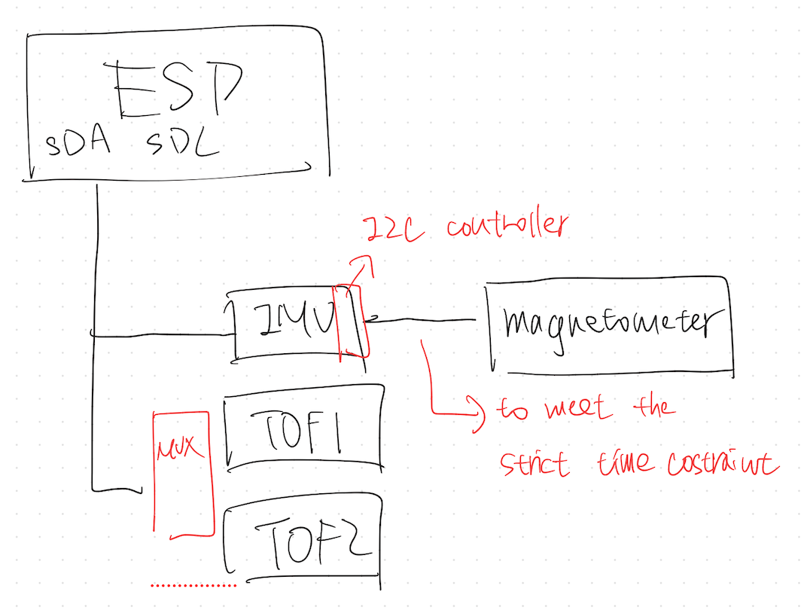
- IMU + magnetometer
  - IMU acts as a sensor hub(9KB FIFO) to store the data from the magnetometer
    - Reason: save power / unified timestamp / release the loading of IMU
  - How to connect
    - Sensor hub / AUX I2C
    - SCL / SDA of the magnetometer connect to AUX I2C of IMU
  - How to boot
    - Init stage(ESP behavior)
      - ESP init I2C (ESP & IMU)
      - Set IMU (ODR / FIFO / interrupt)
      - Set Sensor Hub interaction
        - Which external sensor (e.g., magnetometer)
        - Which control register
        - Which data register
        - Set frequency (same as acc / gyro)
    - Runtime
      - IMU
        - periodically read the external sensor(e.g., megnetometer), and put it into the 9KB FIFO
      - ESP
        - Wait for watermark interrupt or interrupt to read 9KB FIFO
        - Get the accel/gyro + mag + timestamp
  - Github: https://github.com/STMicroelectronics/STMems_Standard_C_drivers/tree/master/lsm6dso_STdC/examples
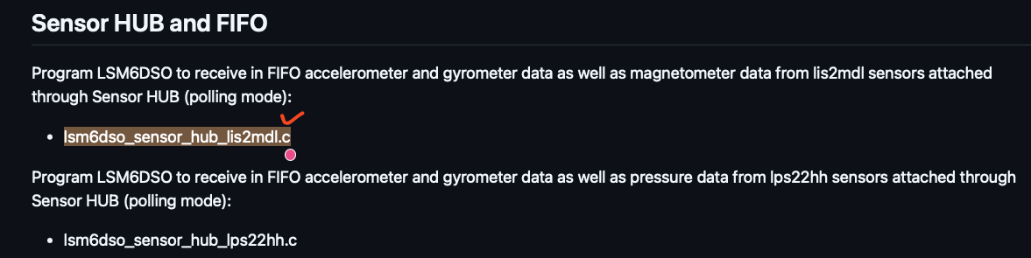
  - Note:
    - Even though the program is only flashed into the ESP, the IMU can still read the data from the magnetometer actively.
    - ESP has to set the Sensor Hub in the IMU
    - IMU would get the data from the magnetometer, and move it to the FIFO based on the instruction given by the ESP
  - SparkFun Provided API
    - readRegister()
    - writeRegister()
    - readMultipleRegisters()
  - set the LSM6DSO as the sensor hub to control LIS2MDL, and store the data in FIFO
    - set sensor hub registers
    - set FIFO
    - activate master
    - read FIFO tag

